CREW REGISTRATION AND INDEMNITY FORM

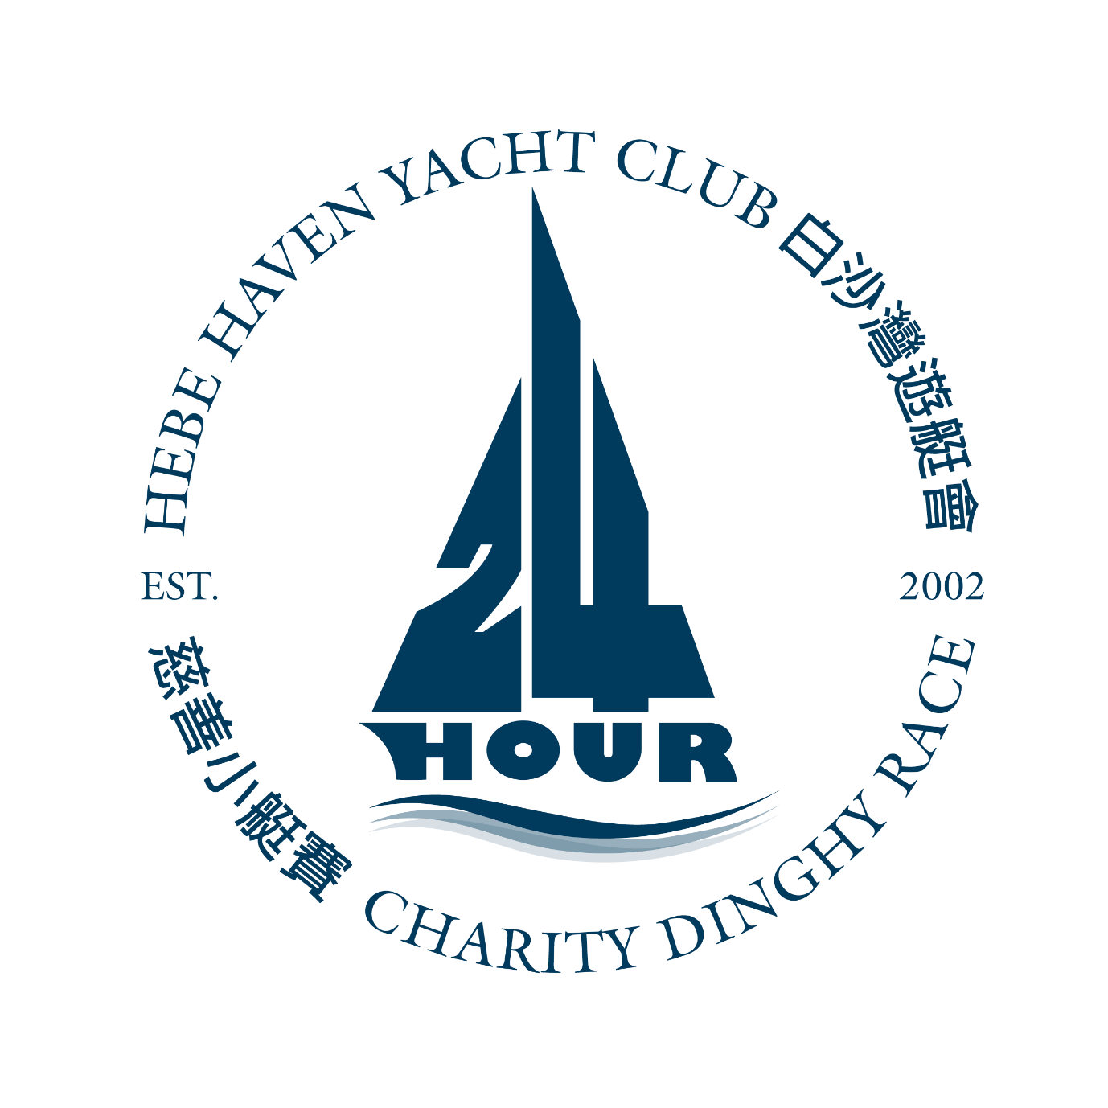
Team Name: ___________________________

Team Captain’s Details:

Name: _______________________________

Home Tel. No._________________________

Signed: _______________________________

Mobile No.________________________

Date: __________________________

SAFETY RULES:

- A properly fitted and fastened buoyancy air or life-jacket must be worn at all times, by all participants when afloat. Any boat carrying competitors who violate this regulation will be stopped by a race officer until such a time as they comply with this rule.

- All participants on the water MUST be able to swim.

- Boat collisions must be avoided in the interest of the safety of all participants on the water

- While sailing, all participants must keep their boats tidy. All halyards should be carefully stowed, and no unnecessary lines or other equipment should be carried aboard.

- All race participants should have clothing appropriate for both day and night sailing conditions. Sun block should be applied to all areas of exposed skin when needed.

- All race participants should have clothing appropriate for both day and night sailing conditions. Sun block should be applied to all areas of exposed skin when needed.
- 3 sailing navigation lights on all race boats must be turned on at 7:00pm.

DINGHY USAGE CONDITIONS:

Team Captains are reminded that they are responsible for returning the dinghy to the Club in the same condition in which it was checked-out. The boat should be checked by the Team Captains before use and any defects or missing equipment should be reported to a member of the Race Committee. If it is found that the dinghy is damaged or has lost equipment, the Team Captain will be held responsible for the cost of repair and/or replacement of any lost or damaged equipment.

DECLARATION (to be signed by ALL team members):

I have read the safety rules included here and in the Sailing Instructions and agree to abide by them for the event. I also agree that Hebe Haven Yacht Club will not be held liable for any personal injuries, fatal or otherwise, or loss or damage to personal items that may be sustained, to myself or any person sailing with me, as a result of participating in this event.

Team Captains should read the Notice of Race and Sailing Instructions thoroughly, taking particular note of those sections applicable to safety, crew registration and age limit.

Please return this form to the Race Office on or before 7:00pm on 19th September 2019. Crew (except under 18 years of age) should sign on the race day at the race office desk. Signatures of the patients or guardians need to be sent to the race office (sailing@hhyc.org.hk) on or before 30th September 2019.
NO. | FULL NAME | EMERGENCY CONTACT NO.  (of friend or relative) | EMAIL | SIGNATURE  (Parent or Guardian to sign if under 18 years of age)
1
2
3
4
5
6
7
8
9
10
11
12
13
14
15
16
17

